Elserag

A Literacy Platform for Special Needs

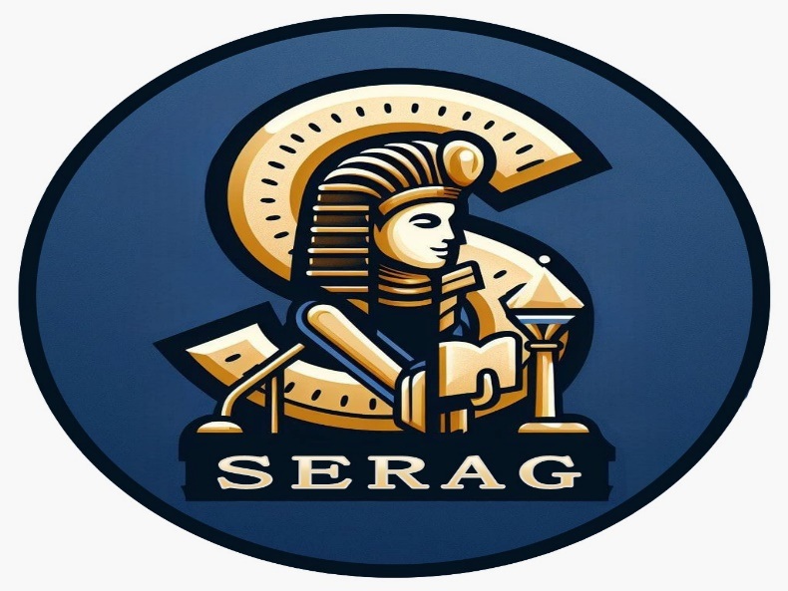

Project Name

Elserag

Team Members

1. Mohamed AbdElrahman Ahmed Elkhlawy.
2. Amina Younis Mohamed.
3. Manar Hussein Mohamed.
4. Norhan Nageh Elabd.
5. Omar Mohamed Elhassan Madny.
6. Sara Nabil Mohamed Kamel.

Business Model Canvas

